Schedule for SAKURA Science Program

Activity at Chiba University (7 days)

July 23 (Thu) – July 29 (Wed)

Your participation is absolutely required.
Online Activity (4 days)

Date: June 25 (Thu), July 2 (Thu), July 9 (Thu), and July 16 (Thu)
Time: 7:00-9:00 PM (JST)

We would like to invite ONE student each for an Invitee (First Choice: Postgraduate Student) from your university to Chiba University.

Who can be Invitees?

All Invitees must meet the following eligibility.

You must be:
- Affiliated to the partner university as an undergraduate, a postgraduate, a postdoctor or a teacher
- 40 years old or younger.
- A citizen of a country that has diplomatic relations with Japan.

You must NOT be:
- Belonged to the private enterprise.
- An active military personnel or a civilian employee of the military service.

It must be your first visit to Japan since you entered your university.
※Short-term stay (around 10 days) for sightseeing will be exception.

You must be able to submit documents as follows:
Documents you have to submit by May 29st (Fri), 2026:
- Sakura Application form (Your Passport photo copy must be attached)

Documents you have to submit by June 30th (Tue), 2026:
- Entry sheet for International Research Session
- Presentation data for International Research Session (Power Point, within 8 pages long)
- Proceeding (within 2 pages long)
- ★VISA photo data
- ★Insurance certificate photo data

Exclusive Benefits for Invitees:

- 7 Days Program – Not hectic program
- Take Lectures – Have chance to take lectures at Chiba University
- Deliver Presentation at International Research Meeting – Gain valuable experience by present your research
- Proceeding to be published
- Participate in SDGs Workshop – Broaden and deepen your thoughts
- Foster Friendship - Meet and foster friendship with friends from ASEAN Universities and Chiba University!!
- Certificate of Participation – Boost your portfolio

What covered under the warranty for Invitees?

- Round-trip Airfare
- Accommodation Fee (Hotel Sunroute Chiba)
- Overseas Travel Insurance fee (Arranged by JST)

What do Invitees need to cover?

- Food and Personal expenses
- Transportation costs (both domestic and in Japan)

【FYI】 About the expenses during your stay in Japan
Approximately 20,000 yen (For 7 days)

How to Apply?

Submit the following documents to TWINCLE Office by May 29th (Fri), 2026.
- Sakura Application form (Your Passport photo copy must be attached)

※Please wait for “First Circular” and “Second Circular” for further instructions.

Deadline to Submit Your Documents

May 29th (Fri), 2026:
- Sakura Application Form (Your Passport photo copy must be attached)

June 30th (Tue), 2026:
- Entry sheet for International Research Session
- Presentation data for International Research Session (Power Point, within 8 pages long)
- Proceeding (within 2 pages long)
- ★VISA photo data
- ★Insurance certificate

Please Note
If we do not receive your application form by the deadline, we might let some other possible university have the available spots for this program.

Other Cautionary Points

【VISA Application】
The necessity of VISA application differs by country. Please confirm your situation with the link below:
Ministry of Foreigh Affairs of Japan:
VISA | Ministry of Foreign Affairs of Japan

※Please see more details on the supplementary document.

【About Passport Photocopy】
Make a photocopy of the page in your passport with your photo on it;

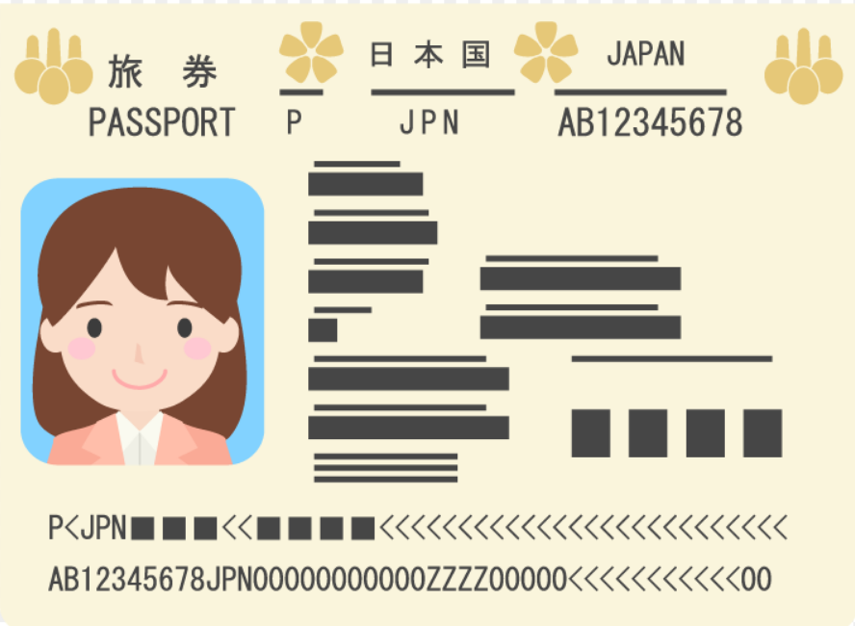
【About Accommodation】
TWINCLE office will book a room at Hotel Sunroute Chiba for you (Single room, with breakfast).

Hotel Sunroute Chiba:
https://www.sunroute.jp/HotelInfo/kanto/chiba/index.html

Online Activities (4 days)

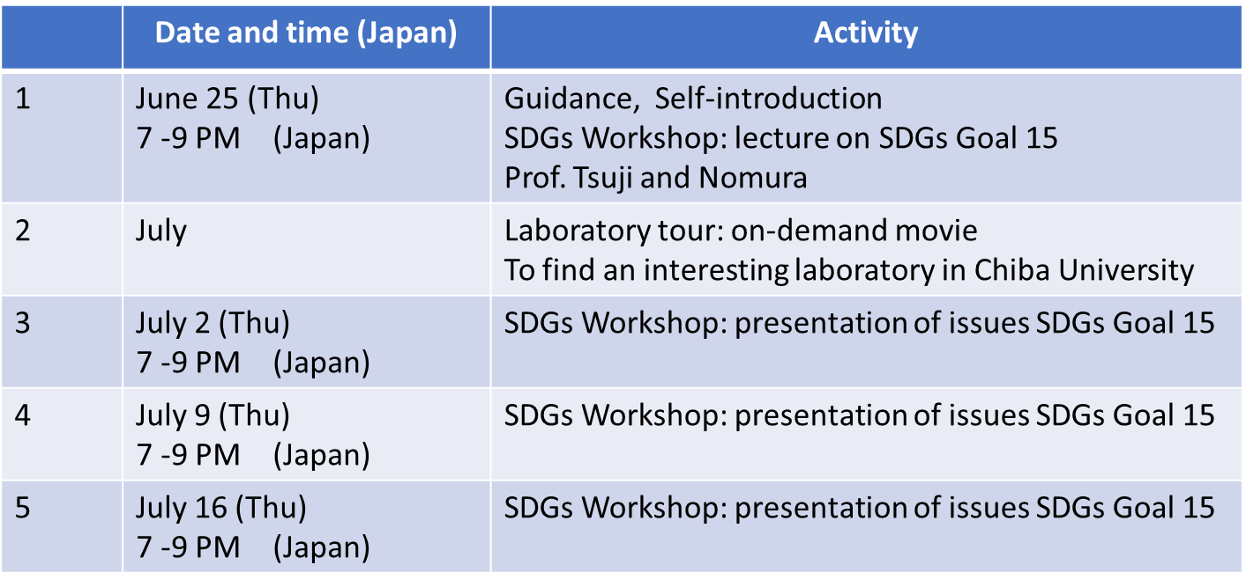

Activity at Chiba University

Date | Activity
July 23 – July 29  (7 days) | Orientation  Ice Breaking  TWINCLE class  International Research Session  SDGs Workshop  Science classes  Excursion  Introduction of Japanese Culture  Final Presentation

About Questionnaires

After this program is finished, you will be required to answer 2 questionnaires before you leave Japan.

- SAKURA Science Questionnaire
- Twincle Questionnaire (SAKURA)

We appreciate your kind understanding and cooperation.
If you have any questions, please feel free to contact us at anytime.


Masami NAKAGAWA
Keiko YOSHINO
TWINCLE Office
Email: edu-twincle@chiba-u.jp

